**Visual Story**

**CONTENTS**

**WHAT YOU NEED TO KNOW**PAGE 3

**CHARACTERS AND CAST**PAGE 5

**THE STORY**PAGE 9

**THINGS THAT MIGHT HELP**PAGE 19

**WHAT YOU NEED TO KNOW**

The Buddha of Suburbia is a co production between Wise Children and the RSC. Based on the Novel by Hanif Kureishi and adapted for stage by Emma Rice and Hanif Kureishi.

It’s a story of 17-year-old Karim who lives in South London in the late seventies. High unemployment, high inflation, food shortages and strikes. But despite the winter of discontent, Karim’s life is about to explode into glorious technicolour as he navigates a path to enlightenment. Or at the very least, Beckenham.

**PERFORMANCE TIMES**

The play is shown in two halves with a 20-minute break in the middle (called the ‘*interval*’).

It is a total of 2 hours and 50 minutes long, including the 20-minute break.

**CONTENT ADVISORY**

Age guidance 13+.

This production features:

* Some scenes of an adult nature (including depictions of nudity and sexual acts)
* Swearing
* Representations of physical violence
* Themes of racial, gender and sexual discrimination (including portrayals of manipulative, forceful and domineering behaviour, as well as grooming)
* Depictions of alcohol and drug misuse
* Loud noises (including music and voices)
* Flashing lights
* Strobe effects
* Smoke and haze
* E-cigarettes
* Incense
* Party Poppers
* Balloons

**ALLERGENS**

Please note that Latex balloons may fall into the audience as part of the performance.

**CHARACTERS**

|  |  |
| --- | --- |
|  | THE STORY FOLLOWS **KARIM** WHO IS 17 IN 1976. |
|  | THIS IS KARIM’S MOTHER, MARGARET |
|  | AND HIS FATHER HAROON |
|  | EVA IS THEIR NEIGHBOUR |
|  | CHARLIE IS EVA’S SON |
|  | KARIM’S AUNTIE JEETA |
|  | HIS UNCLE ANWAR |
|  | THEIR DAUGHTER JAMILA IS KARIM’S BEST FRIEND. |
|  | SHE IS MARRYING CHANGEZ |
|  | MATHEW PYKE IS A THEATRE DIRECTOR. |
|  | ELEANOR IS AN ACTRESS |

**VISIT OUR WEBSITE FOR MORE INFORMATION ABOUT OUR CAST, CHARACTERS AND CREATIVES****.**

**THE STORY**

It’s the 3rd of May, 1979, and Karim, is throwing a party for all his friends and family to celebrate his new job.

Life wasn’t always this good, and he takes us back three years to the start of our story.

It’s 1976 and we’re in Karim’s childhood home.

His parents are unhappily married.

Haroon, his father, spends his spare time doing yoga and visiting Eva, their neighbour.

Margaret, his mother, spends her time washing up and worrying that Haroon will leave her forEva.

Karim tells his dad he’s thinking about becoming an actor.

Haroon invites him along to a party at Eva’s house.

Charlie, her son, is a real rebel and Karim is totally in love with him.

Charlie leads Karim upstairs to his room.

They share a joint, then Karim runs out of the room only to see his dad laughing and having sex with Eva.

Disgusted, Karim goes back to Charlie, and realises Charlie wants Karim to touch him.

Eva and Haroon catch them together.

Back home, Karim tells his dad that neither of them will ever mention what happened again.

Karim goes to visit his Auntie Jeeta and Uncle Anwar at their shop.

He wants to see their daughter, Jamila, his best friend.

They’ve been having sex with each other for a few years now.

Karim tries to talk to Jamila about his father’s affair but she waves his concerns away and tries to have sex with him instead.

Jamila tells him that her father has gone on hunger strike to force her to accept an arranged marriage.

Jamila gives in and soon, Changez - Jamila’s husband-to-be - arrives in London.

Jamila thinks he is an idiot and wants nothing to do with him.

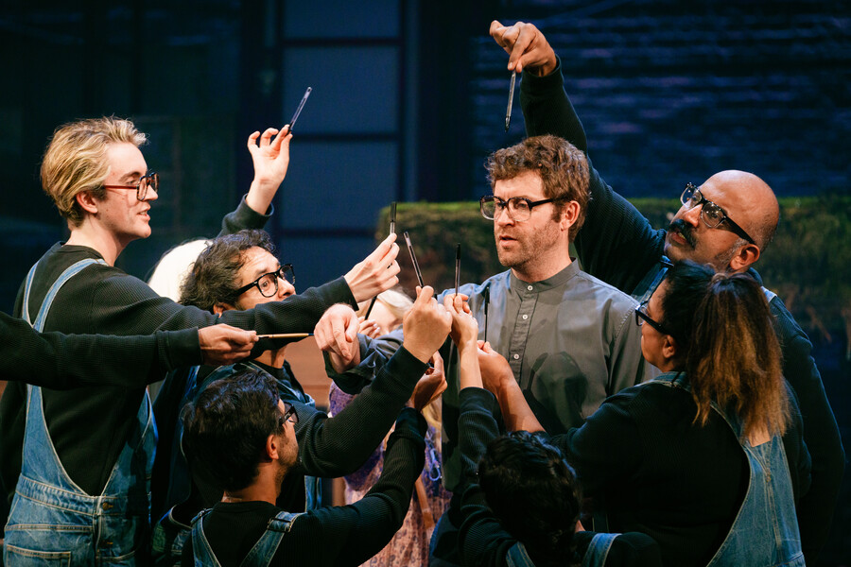

Eva gets Karim a job as an actor, playing Mowgli in the JungleBook.

The director puts pressure on Karim to wear just a loin cloth and to put on a fake Indian accent.

The show is a success, though his father and Jamila disapprove.

After the play, Karim meets Matthew Pyke, an esteemed theatre director who offers him a role in his next show.

It’s now 1977 and Karim is in rehearsals for Pyke’s new show.

Karim meets Eleanor, one of the posh actors, and falls in love with her.

Pyke invites Karim and Eleanor round for a party, but Pyke and his wife, are interested in more than dinner - and Karim and Eleanor get pulled into a wild foursome with them.

Karim is not very interested in it but worries his part will get cut in the play if he doesn’t participate.

Jamila’s and Changez’ marriage is still not going well. Jamila refuses to sleep with Changez and he’s completely useless at helping in her dad’s shop.

To make things worse, Changez has an argument with Jamila's dad, Anwar in the street and accidentally gives him a fatal heart-attack after hitting him with a Dildo.

Jamila and Changez leave the family home and move to a commune. Even though Jamila starts to see someone else, Changez tells Karim that he loves it there.

As the first night of Pyke’s play approaches, Changez is viciously attacked in the street by racist thugs.

He ends up in hospital but survives and Jamila organises a protest march. Karim agrees to join her but he finds out that Eleanor has been cheating on him and lets Jamila down.

The play is a triumph.

Karim’s parent are very proud of him but he’s broken-hearted after the split from Eleanor and Jamila is still angry with him about the protest march.

He reconnects with Charlie – who is now living the life of a rock star. They spend 6 months smoking, drinking and doing drugs.

As their relationship becomes more and more co-dependent and destructive Karim finally realises his mistake and leaves Charlie to his fate.

Karim returns home and starts to reconnect with his family and friends, discovering how their lives have changed while he’s been away.

Out of the blue, Karim gets a phone call.

He’s got a job on a big soap opera and we’re back in the party from the beginning.

Karim reflects on how painful, cruel and messy life can be and looks forward to the changes the future will bring.

**THINGS THAT MAY BE USEFUL**

**AUDIO NOTES**

You can listen to the audio notes forThe Buddha of Suburbia below or download the notes as an MP3 file to listen later.

[LISTEN TO THE AUDIO NOTES](https://soundcloud.com/barbican-access-guides/audio-introduction-the-buddha-of-suburbia?)

**AUDIO INTRODUCTION TRANSCRIPT**

Read a transcript of the audio notes for The Buddha of Suburbia below.

[READ THE AUDIO INTRODUCTION TRANSCRIPT](https://www.barbican.org.uk/sites/default/files/documents/2024-10/Audio%20introduction_%20The%20Buddha%20of%20Suburbia.pdf)

**A FILMED VISUAL SYNOPSIS WITH BSL**

Watch the British Sign Language synopsis of The Buddha of Suburbia below.

This video features British Sign Language interpreter Clare Edwards.

[WATCH THE BSL SYNOPSIS](https://youtu.be/ma71c3kiJAc?si=AtFdF33_jsX_Q0-k)

**SONIC STORY**

We offer a sonic story forThe Buddha of Suburbia.This is a graphic which highlights the key sounds from throughout the performance. It's available to all audience members, but we hope it will be particularly useful for anyone who might benefit from understanding the sensory elements of the show before they see it.

[VIEW THE SONIC STORY](https://www.barbican.org.uk/sites/default/files/documents/2024-10/Sonic%20Story_The%20Buddha%20of%20Suburbia.pdf)