List of objects proposed for protection under Part 6 of the Tribunals, Courts and Enforcement Act 2007 (protection of cultural objects on loan).

Sudhir Patwardhan (1949) (Indian)

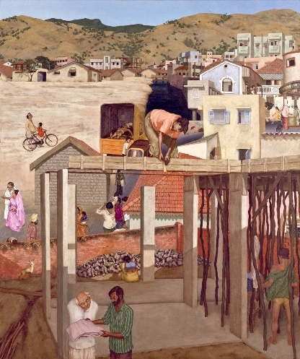

© Peabody Essex Museum, Salem, Massachusetts

Lender's name and address: | Peabody Essex Museum  161 Essex Street, Salem, MA 01970  Salem, Massachusetts
Title: | Town
Date of creation: | 1984
Type / Medium: | Oil on canvas
Object dimensions: | 156.8 x 186.7 cm
Description of appearance/identifying marks: | N/A
Place of manufacture: | India
Credit line: | Gift of the Chester and Davida Herwitz Collection 2001
Accession Number: | E301094
Provenance: | Acquired by Peabody Essex Museum in 2001 as a gift from the Chester and Davida Herwitz Collection. The work was part of the Collection in 1985, and is presumed to have been acquired from the artist.  Ownership between 1933-45: Not created until 1984.

Sudhir Patwardhan (1949) (Indian)

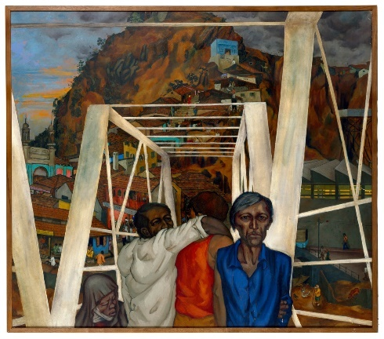

© Peabody Essex Museum, Salem, Massachusetts

Lender's name and address: | Peabody Essex Museum  161 Essex Street, Salem, MA 01970  Salem, Massachusetts
Title: | Overbridge
Date of creation: | 1981
Type / Medium: | Oil on canvas
Object dimensions: | 141 x 125.7 (cm)
Description of appearance/identifying marks: | N/A
Place of manufacture: | India
Credit line: | Peabody Essex Museum, Salem, Massachusetts
Accession Number: | E301218
Provenance: | Acquired by Peabody Essex Museum in 2003 as a gift from the Chester and Davida Herwitz Collection. The work was part of the Collection in 1985, and is presumed to have been acquired from the artist.  Ownership between 1933-45: Not created until 1981.

Gieve Patel (1940 - 2023) (Indian)

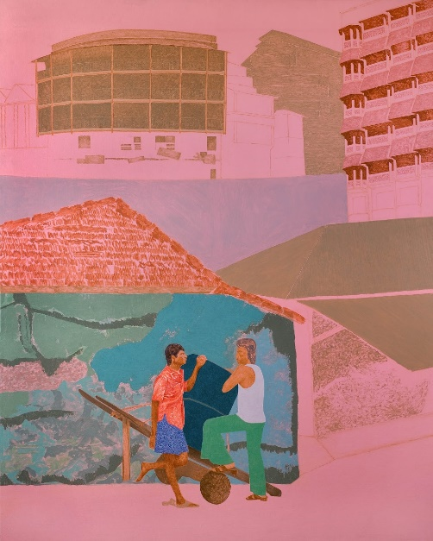

© Peabody Essex Museum, Salem, Massachusetts

Lender's name and address: | Peabody Essex Museum  161 Essex Street, Salem, MA 01970  Salem, Massachusetts
Title: | Two Men With Handcart
Date of creation: | 1979
Type / Medium: | Oil on canvas
Object dimensions: | 176.5 x 144.8 (cm)
Description of appearance/identifying marks: | N/A
Place of manufacture: | India
Credit line: | Peabody Essex Museum, Salem, Massachusetts
Accession Number: | E301289
Provenance: | Acquired by Peabody Essex Museum in 2003 as a gift from the Chester and Davida Herwitz Collection. The Collection acquired the work in 1981, and is presumed to have been acquired from the artist.  Ownership between 1933-45: Not created until 1979.

Tyeb Mehta (1925 - 2009) (Indian)

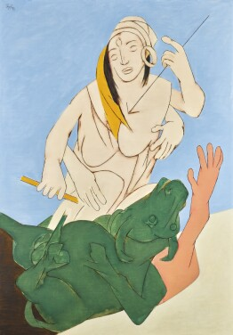

© Private Collection

Lender's name and address: | Private Collection c/o  GENTEX MERCHANTS PRIVATE LIMITED  22, Dr. A.P.J Abdul Kalam Road,  New Delhi – 110 01
Title: | Durga Mahisasura Mardini
Date of creation: | 1993
Type / Medium: | Acrylic on canvas
Object dimensions: | 149.5 x 105 (cm)
Description of appearance/identifying marks: | N/A
Place of manufacture: | India
Credit line: | Mr. Lakshmi Niwas Mittal and Mrs. Usha Mittal (Gentex Merchants Private Limited, India)
Accession Number: | N/A
Provenance: | Acquired by the lender from Sotheby's Art Services (India) Private Limited in November 2018. Acquired by Sotheby’s directly from the artist in 1993.  Ownership between 1933-45: Not created until 1993.

Bhupen Khakhar (1934 - 2003) (Indian)

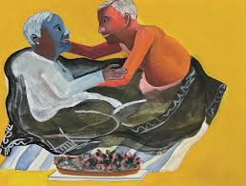

© Private Collection

Lender's name and address: | Galerie Mirchandani + Steinruecke  Breach Candy Gardens  Flat 8, 3rd Floor  68 Bhulabhai Desai Road  Mumbai 400 026
Title: | Grey Blanket
Date of creation: | 1998
Type / Medium: | Watercolor on paper
Object dimensions: | 30 x 40 (cm)
Description of appearance/identifying marks: | N/A
Place of manufacture: | India
Credit line: | Collection: Bernhard Steinruecke
Accession Number: | N/A
Provenance: | Acquired by the owner directly from the artist  Ownership between 1933-45: Not created until 1998.

