List of objects proposed for protection under Part 6 of the Tribunals, Courts and Enforcement Act 2007 (protection of cultural objects on loan).
Tyeb Mehta (1925 - 2009) (Indian)
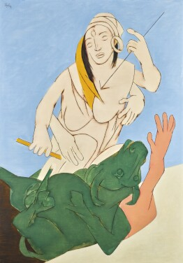

© Private Collection

Lender's name and address: | Private Collection c/o  GENTEX MERCHANTS PRIVATE LIMITED  22, Dr. A.P.J Abdul Kalam Road,  New Delhi – 110 01
Title: | Durga Mahisasura Mardini
Date of creation: | 1993
Type / Medium: | Acrylic on canvas
Object dimensions: | 149.5 x 105 (cm)
Description of appearance/identifying marks: | N/A
Place of manufacture: | India
Credit line: | Mr. Lakshmi Niwas Mittal and Mrs. Usha Mittal (Gentex Merchants Private Limited, India)
Accession Number: | N/A
Provenance: | Acquired by the lender from Sotheby's Art Services (India) Private Limited in November 2018. Acquired by Sotheby’s directly from the artist in 1993.  Ownership between 1933-45: Not created until 1993.

Bhupen Khakhar (1934 - 2003) (Indian)
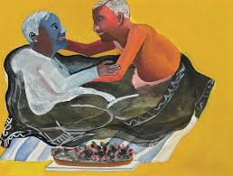

© Private Collection

Lender's name and address: | Galerie Mirchandani + Steinruecke  Breach Candy Gardens  Flat 8, 3rd Floor  68 Bhulabhai Desai Road  Mumbai 400 026
Title: | Grey Blanket
Date of creation: | 1998
Type / Medium: | Watercolor on paper
Object dimensions: | 30 x 40 (cm)
Description of appearance/identifying marks: | N/A
Place of manufacture: | India
Credit line: | Collection: Bernhard Steinruecke
Accession Number: | N/A
Provenance: | Acquired by the owner directly from the artist  Ownership between 1933-45: Not created until 1998.

