Autism and Cinema:
An Exploration of Neurodiversity
Thu 2 - Wed 29 Apr 2020
www.barbican.org.uk/whats-on/2020/series/autism-and-cinema-an-exploration-of-neurodiversity
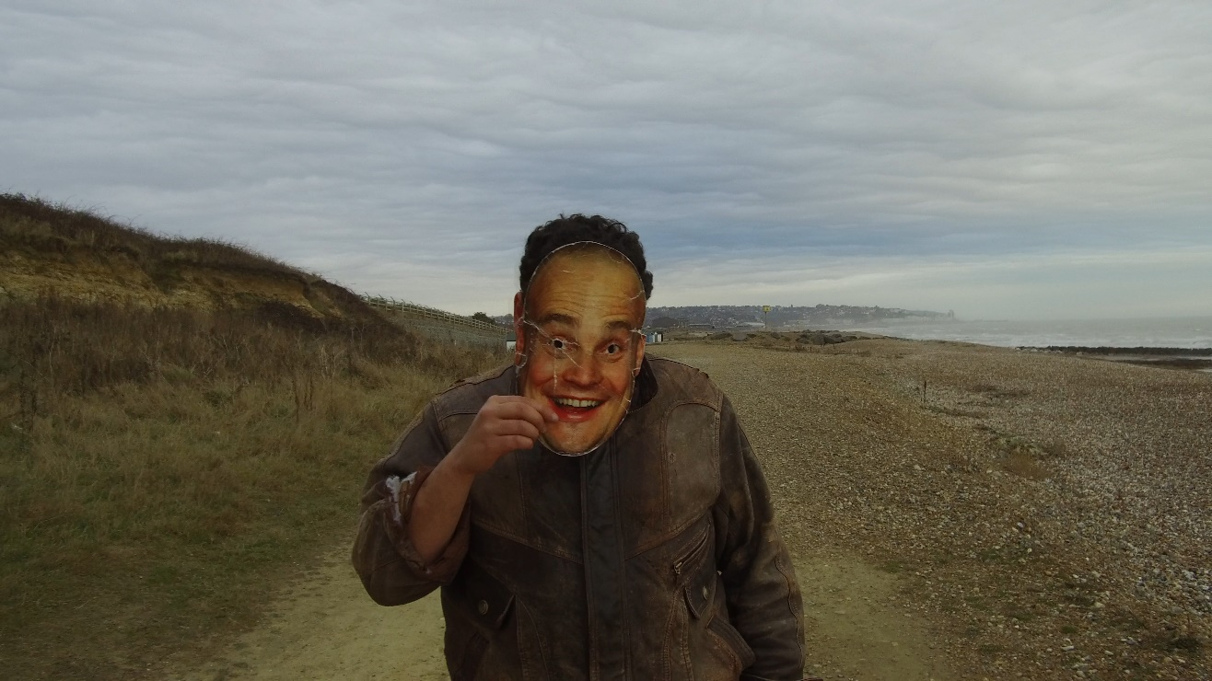
The Mask, UK 2017, Dir Sharif Peraud
Barbican Cinema and Queen Mary University of London are pleased to present Autism and Cinema: An Exploration of Neurodiversity; a season that debates new ideas arising from the relationship between autism and cinema.
Bringing together a diverse selection of films, ranging from documentary to animation, and genre-twisting fiction to experimental filmmaking from within the autistic community, this programme asks how the language of cinema can be challenged and changed by autistic perspectives.
Typically, cinema has depicted characters with autism from the outside, looking in with fascination at a high-functioning or magical character who throws out of joint the ‘neurotypical’ lives of those around them.
A cinema reflective of autism and the experience of neurodiversity is rare. Yet it has much to offer our understanding of inner and outer life, ushering in new sensory and relational ways of being in the world. It is part of Inside Out, a year-long Barbican cross arts season exploring the relationship between our inner lives and creativity. It is presented in collaboration with the Centre for Film and Ethics at Queen Mary University of London.
The season opens with Temple Grandin (US 2010 Dir Mick Jackson), a biopic of the accomplished autistic thinker and advocate who transformed the cattle farming industry.
The film attempts to visualise for the audience Temple’s inner world – one in which sights and sounds are accentuated, and thoughts run ‘like a VCR tape.’ The screening will be followed by an exclusive filmed interview with Temple Grandin, discussing the film and her experience of autism.
Other highlights include the documentary Life Animated (US 2016 Dir Roger Ross Williams), which examines the place of animation in the evolving mind map of a child, where the medium of film becomes a toolkit and a shared vocabulary; and Mulholland Drive (US 2001, David Lynch), set in the winding roads and dark recesses of Hollywood, the curators suggest the film steps beyond neurotypical ways of comprehending (such as reading body language and inferring emotions from faces), and breaks convention by asking viewers to experience story unbound by linear structure.
The season also includes rarely screened titles such as Jigsaw (UK 2004 Dir Robina Rose), Scrapbook (Canada 2015 Dir Mike Hoolboom) and the UK premiere of the new 2K restoration, with English subtitles, of Le Moindre geste (France 1971 Dirs Jean-Pierre Daniel & Fernand Deligny); these films reject psychiatric institutions and embrace progressive schools and rural settings, encountering their young subjects experimentally through movement and gesture as well as language.
All the films are Relaxed Screenings and include live introductions and post-screening discussions involving members of the autistic community, artists, activists, and academics. All screening events will take place at Barbican Cinema 2&3 and Café which has recently been awarded the Autism Friendly Award by the National Autistic Society.
Janet Harbord, Professor of Film at Queen Mary, University of London, comments:
‘This programme explores the rich and multifaceted nature of an autistic apprehension of the world by looking with autism rather than at it. The autistic capacity for visual thinking, for a heightened attention to the object-world, and for bringing into the foreground what is often lost to the background, characterize this series of films, demonstrating an historical affinity between autism and cinema.’
Highlights from the season will be screened in selected cinema venues across the UK.
Temple Grandin (12A*) + ScreenTalk
US 2010, Dir Mick Jackson, 107 min digital presentation
Thu 2 Apr 2020, 18:00, Barbican Cinema 3
Drawn from the subject’s own memoirs, Temple Grandin details the life story of the incredible autistic thinker and advocate who transformed the cattle farming industry.
Diagnosed at a time when long-term institutional care was still common, Grandin overcame all odds to pursue her education. The film attempts to visualise for the audience Temple’s inner world – one in which sights and sounds are accentuated, and thoughts run ‘like a VCR tape’. And it depicts her struggles as she uses her own sensory experiences to help develop new approaches to animal farming.
The screening will be introduced by Queen Mary academics Janet Harbord and Steven Eastwood, and will be followed by an exclusive filmed interview with Temple Grandin discussing the film and her experience of autism.
Le Moindre geste (PG*) + ScreenTalk Mathias Winter and Damian Milton
France 1971 Dirs Jean-Pierre Daniel, Fernand Deligny, Josée Manenti
96 min digital presentation
Sun 5 Apr 2020, 15:00, Barbican Cinema 3
First screened in the critics’ week at Cannes Film Festival in 1971, this one-of-its kind docu-drama arises from the work of anti-psychiatry guerrilla Fernand Deligny.
Deligny rejected the oppression of psychiatric institutions and lived with autistic children in experiments, or ‘tentatives’.
Shot over two years, Le Moindre geste presents Yves, a young autistic man escaped from a psychiatric institution, and a teen from the local village, as they explore the Cevennes hills. When a situation becomes a crisis, Yves responds with anachronistic offerings that exhibit their own logic.
It screens here with Scrapbook: a film offering a twist on the idea of time travel, it overlays footage shot in 1967 in an Ohio residential centre for neurodiverse children with commentary, recorded 45 years later, by one of the women in it.
Introduced by Queen Mary academics Janet Harbord and Steven Eastwood, the film is followed by a ScreenTalk with Mathias Winter and Dr Damian Milton, experts on the life and work of Deligny.
Mulholland Drive (15) + Introduction by Georgia Kumari Bradburn
US 2001, Dir David Lynch, 147 min digital presentation
Tue 7 Apr 2020, 20:15, Barbican Cinema 3
Set in the winding roads and dark recesses of Hollywood, Lynch’s labyrinthine film has attracted much hypothesis.
What if we were to resist the compulsion to solve the film as though it were a puzzle, or infer coherent and intentional subjects from the bodies on screen? What if, instead, we were to experience the chambers and onscreen events as belonging to a cinema not bound by theories of mind, its characters ones who ‘fracture and recombine like flesh caught in a kaleidoscope’ (Roger Ebert).
Mulholland Drive screens with The Mask (UK 2017 Dir Sharif Peraud 4 min digital presentation), a remarkable first-person account of methods for autistic being-in-the-world, and a wry observation of personality as role play. As he journeys along a coastal footpath, the writer-director describes what it means to have autism while all the time wearing his favourite celebrity mask.
Introduced by Queen Mary academics Janet Harbord and Steven Eastwood, and Georgia Kumari Bradburn, author of The Autistic Film Critic blog.
Life, Animated (PG*) + ScreenTalk
US 2016 Dir Roger Ross Williams 92 min digital presentation
Sat 25 Apr 2020, 15:00,Barbican Cinema 3
Based on the book Life Animated: A Story of Sidekicks, Heroes and Autism, this documentary examines the place of animation in the evolving mind map of a child.
Constructed from home video footage, hand-drawn animation and scenes from Disney movies, the film explores the power of animated fable to transfer experience from one domain to another. Following the passion of their son and engaging with the world of Disney, the circle of people around Owen come to understand film as a tool-kit, a strong attractor, a shared vocabulary.
It screens here with the award-winning animated documentary A is for Autism (UK 1992 Dir Tim Webb 11 min, digital presentation). Each design in the film is based on drawings by autistic contributors and the soundtrack combines their thoughts with piano and flute music performed by autistic performers.
Following the screening, the film’s director Tim Webb, will be in conversation with Carla MacKinnon, artist and founder of Rich Pickings.
Jigsaw (PG*) + ScreenTalk
UK 2004 Dir Robina Rose 67 min digital presentation
Wed 29 Apr 2020, 18:00,Barbican Cinema 3
Produced in 2004 just before autism diagnoses began to rise, Jigsaw sought to depict a little-known condition in a new light.
Robina Rose’s film focuses on the preoccupations of a group of autistic children in a specialist school in London. Rose’s immersive style engages with the content of the children’s activities bringing the audience into contact with the structure and content of their thoughts and actions.
Experimental methods, such as detailed close-ups and drawn-out scenes, enable forms of viewer observation which encourage new reflections on meaning and content, in order to change our perspectives on neurodiversity.
It screens with Terry (UK 2013, Dir Annis Joslin, 15 min) Lightsteps (UK 2020, Dir Kate Adams, 3 min) and Outside In, (UK 2016, Dir Jesse Currie, 4 min), short films in collaboration with or by autistic people and filmmakers, working with the support of Project Art Works and Biggerhouse Film.
After the screening, Rose is in conversation with Queen Mary academic Dr Bonnie Evans, and Kate Adams, artist, activist and co-founder of Project Art Works.
Notes to Editors
For further information contact:
Ian Cuthbert, Communications Manager, Cinema
ian.cuthbert@barbican.org.uk/ 07980 925 352
Sarah Harvey, Barbican Cinema Press Consultant
sarah@sarahharveypublicity.co.uk/ 07958 597426
Ticket prices:
Box office: 020 7638 8891 www.barbican.org.uk
Standard ticket price: £12/ Members: £9.60/ Concessions: £11/ Young Barbican: £5
About Barbican Cinema
We connect audiences with a curated programme of international cinema; from celebrated filmmakers to ground-breaking and under-heard voices from past and present. Our programme ranges from thematic seasons that respond to today’s world, to new releases, Screentalks, cross-artform collaborations, family events, access screenings, cross-artform collaborations and event cinema that presents the performing arts on screen.
We showcase the work of emerging filmmakers, as well as less familiar work of exceptional filmmakers from the UK and around the world. We champion the work of Barbican young programmers and give stage to emerging musicians in our ongoing film & live music series which includes our flagship collaboration with the Guildhall School of Music & Drama.
As part of a cross-arts centre, our cinemas are a cultural space for people to share the viewing experience.
We strive to be inclusive in everything we do; providing platforms for the widest possible range of filmmakers and ensuring we are an open, welcoming and accessible venue for all our audiences. We programme free offsite events in east London, offer reduced price tickets to 14-25 year olds through the Young Barbican membership scheme and special student ticket prices.
About the Autism through Cinema Project
https://www.autism-through-cinema.org.uk/
Autism through Cinema is a multi-disciplinary research project built around film archaeology and film practice, led by the Centre for Film and Ethics at Queen Mary University of London, as part of a research project supported by Wellcome.
Working with an extensive range of collaborators, the project examines the role of the moving image (medical film, narrative cinema, documentary) in the historical emergence and understanding of autism. The research then investigates the potential of autism to open up the neurotypical language of cinema.
The project begins with the examination of films from medical archives at pivotal moments in the twentieth century. In the second stage, the findings of archival research act as the focal point for workshops leading to participatory filmmaking and experimentation. The final phase of Autism through Cinema offers a new form of cinema informed by neurodiverse experience.

This project is made possible by a Collaborative Award in Humanities and Social Sciences from the Wellcome Trust.
About the Barbican
A world-class arts and learning organisation, the Barbican pushes the boundaries of all major art forms including dance, film, music, theatre and visual arts. Its creative learning programme further underpins everything it does.
Over a million people attend events annually, hundreds of artists and performers are featured, and more than 300 staff work onsite.
The architecturally renowned centre opened in 1982 and comprises the Barbican Hall, the Barbican Theatre, The Pit, Cinemas 1, 2 and 3, Barbican Art Gallery, a second gallery The Curve, public spaces, a library, the Lakeside Terrace, a glasshouse conservatory, conference facilities and three restaurants. The City of London Corporation is the founder and principal funder of the Barbican Centre.
The Barbican is home to Resident Orchestra, London Symphony Orchestra; Associate Orchestra, BBC Symphony Orchestra; Associate Ensembles the Academy of Ancient Music and Britten Sinfonia, Associate Producer Serious, and Artistic Partner Create. Our Artistic Associates include Boy Blue, Cheek by Jowl, Deborah Warner, Drum Works and Michael Clark Company.
The Los Angeles Philharmonic are the Barbican’s International Orchestral Partner, the Australian Chamber Orchestra are International Associate Ensemble at Milton Court, and Jazz at Lincoln Center Orchestra are International Associate Ensemble.
Find us on Facebook | Twitter | Instagram | YouTube | Spotify
About Inside Out
Autism and Cinema at the Barbican and the UK tour of highlights from the season is supported by Wellcome as part of Inside Out is a Barbican cross arts year-long season that explores the relationship between our inner lives and creativity.
Throughout 2020, Inside Out will showcase the work of artists who have found pioneering ways to articulate their innermost thoughts, feelings and desires, and how this can help us to better understand ourselves and empathise with each other’s experience of the world.
The programme will interrogate themes such as identity, self-expression and how we shape our private selves in a world in which we are more socially connected than ever. It will highlight courageous artists and individuals who have challenged society’s definition of them, including those that have found ways to express themselves during times of censorship.

