Members’ wine dinner
In association with

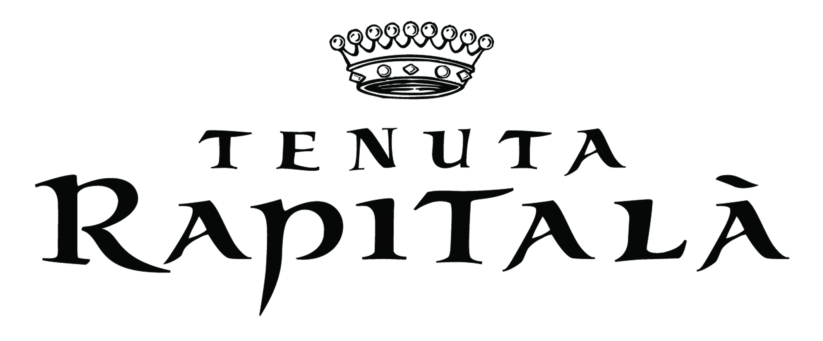

Thursday 6th June 2019, 7.15pm for 7.45pm

£45 per person, including service charge

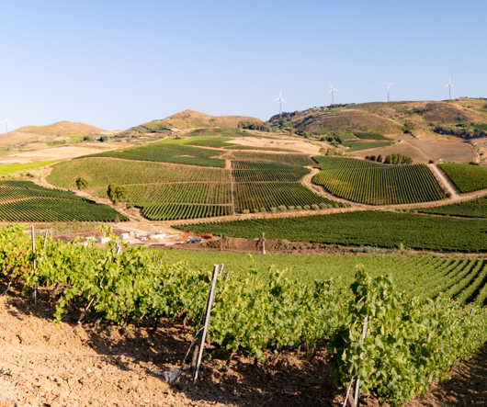

We are delighted to organise a special dinner with wines from this Sicilian Vineyard.

Our Head Chef, Clifton D’Souza, has created a special menu to accompany their wines.

Reception Drink – Girillo Viviri
Pistachio, olives and taralli

Starter - Tenuta Rapitalà Grand Cru Chardonnay
White asparagus, poached egg, crispy pancetta

Main Course – Nero D’Avola Campo Reale
Brasied brisket of beef, pearl barley, Cavolo Nero, red wine jus

Dessert – Rosato Siciliano Rosammuri
Pistachio filo cannoli, pistachio cream, star anise ice cream

Coffee

Please inform us in advance of any dietary requirements

Background

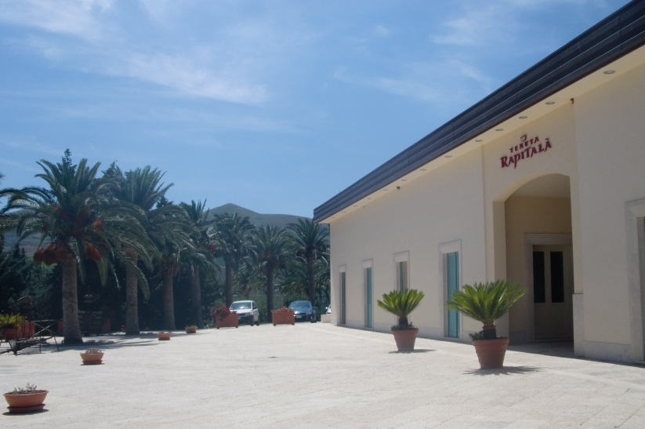
Rapitalà is a real name and comes from the Arabic “Rabidh-Allah” – the “river of Allah”, from the stream that flows among the vineyard. Rapitalà is one of Sicily’s most prestigious wineries and was founded by the love between a French count, Hugues Bernard de la Gatinais, and a Sicilian woman, Gigi Guarrasi. The result was a perfect mix between French art in making wine and the Sicilian culture and flavours. Newly dug natural chalk underground cellar for ageing the wine means the quality of their sparkling and growing range of still wines is going from strength to strength.

